Name:S.VIGNESH
Reg.No:192512378

22. Prolog Program to Check Whether a Particular Bird Can Fly or Not
Aim
To write and execute a Prolog program to determine whether a particular bird can fly or cannot fly using facts, rules, and queries.
Algorithm
- Start the program.
- Define facts for different birds.
- Define facts for birds that can fly.
- Define facts for birds that cannot fly.
- Create a rule to check whether a given bird can fly.
- Enter the name of a bird as a query.
- Check whether the bird is present in the can_fly database.
- If the bird is present, return true.
- If the bird is not present, return false.
- Display the result.
- Stop the program.

PROGRAM:
% Bird Flying Program

% Birds
bird(eagle).
bird(parrot).
bird(pigeon).
bird(crow).
bird(sparrow).
bird(penguin).
bird(ostrich).
bird(emu).

% Birds that can fly
can_fly(eagle).
can_fly(parrot).
can_fly(pigeon).
can_fly(crow).
can_fly(sparrow).

% Birds that cannot fly
cannot_fly(penguin).
cannot_fly(ostrich).
cannot_fly(emu).

% Rule to check whether a bird can fly
bird_can_fly(Bird) :-
can_fly(Bird).

% Rule to check whether a bird cannot fly
bird_cannot_fly(Bird) :-
cannot_fly(Bird).
INPUT:
?- bird_can_fly(penguin).
OUTPUT:
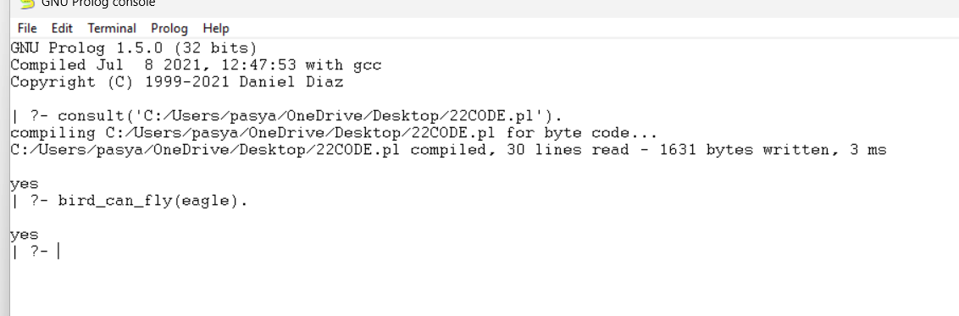
Result
Thus, the Prolog program to determine whether a particular bird can fly or not was successfully implemented and executed, and the required queries produced the expected results.

